**PROJECT : Analytics for Hospitals Health-Care Data**

**NAME : SINEKA V**

**TEAM ID : PNT2022TMID00675**

**ROLL NO : 211419104254**

**BATCH NO : B4-4M6E**

### PROJECT : AIRLINES DATA ANALYTICS FOR AVAITION INDUSTRY

**ASSIGNMNET NO : 01**

**ASSIGNMNET NO : 01**

**DATA EXPLORATION:**

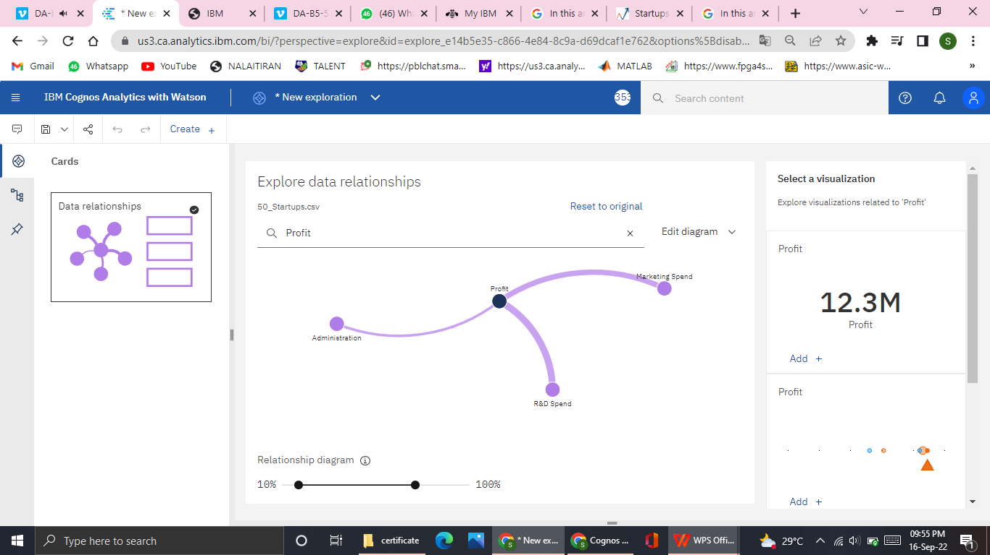

**DATA VISUALIZATION**

**Profit by State colored by Profit(AVERAGE) - BAR GRAPH**

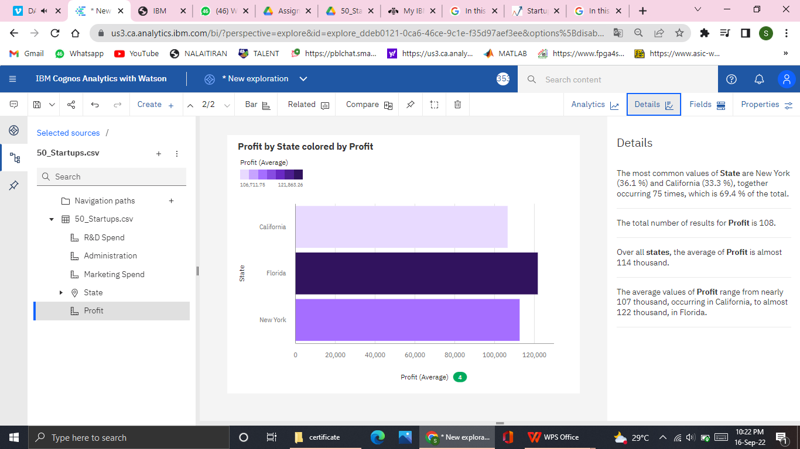

**Profit by State(PIE CHART)**

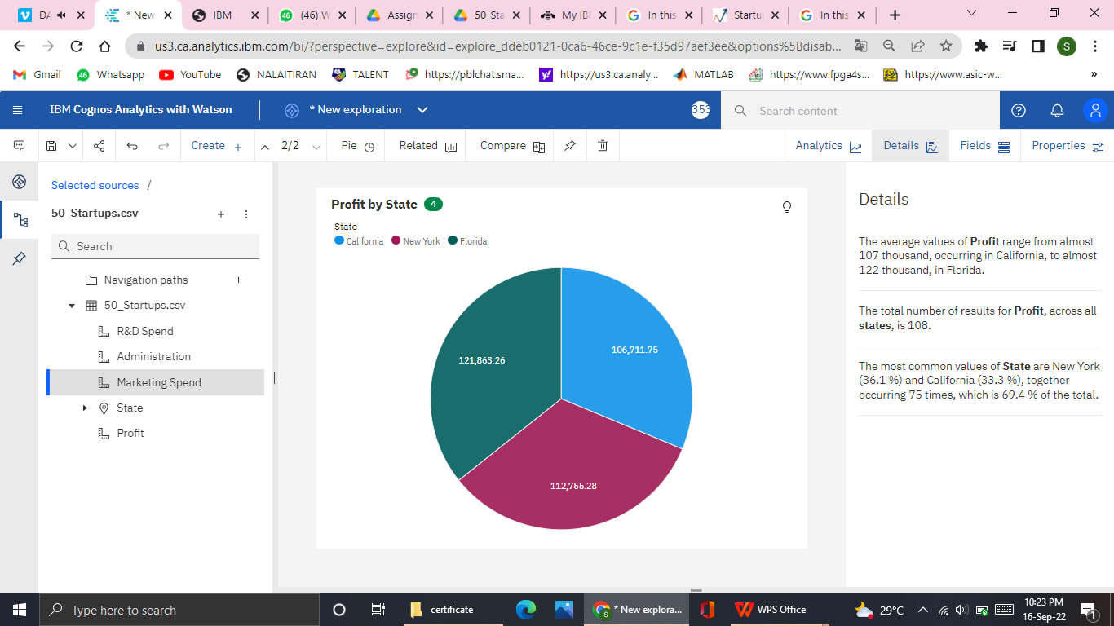

Newyork State has high profit rate when compared to all other states.

**Profit for State and Marketing Spend (CROSS TABLE)**

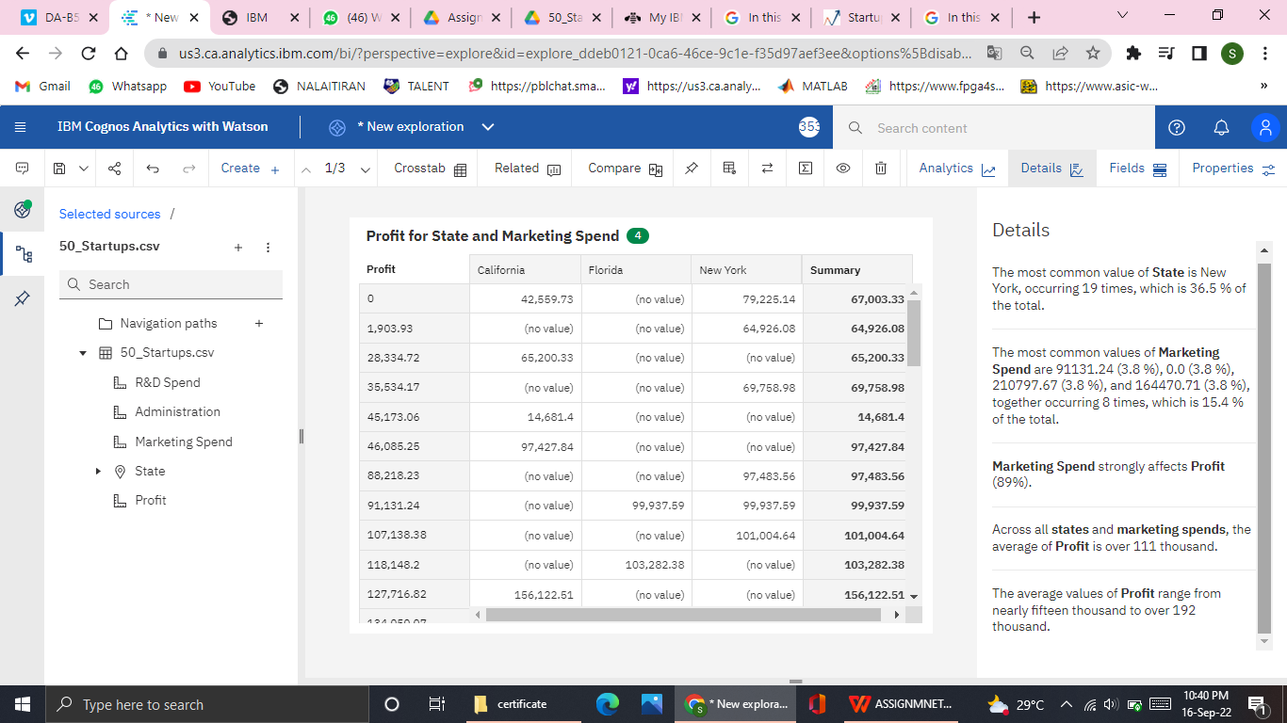

**Marketing Spend** strongly affects **Profit**

**Administration and Profit by State ( Line and Column)**

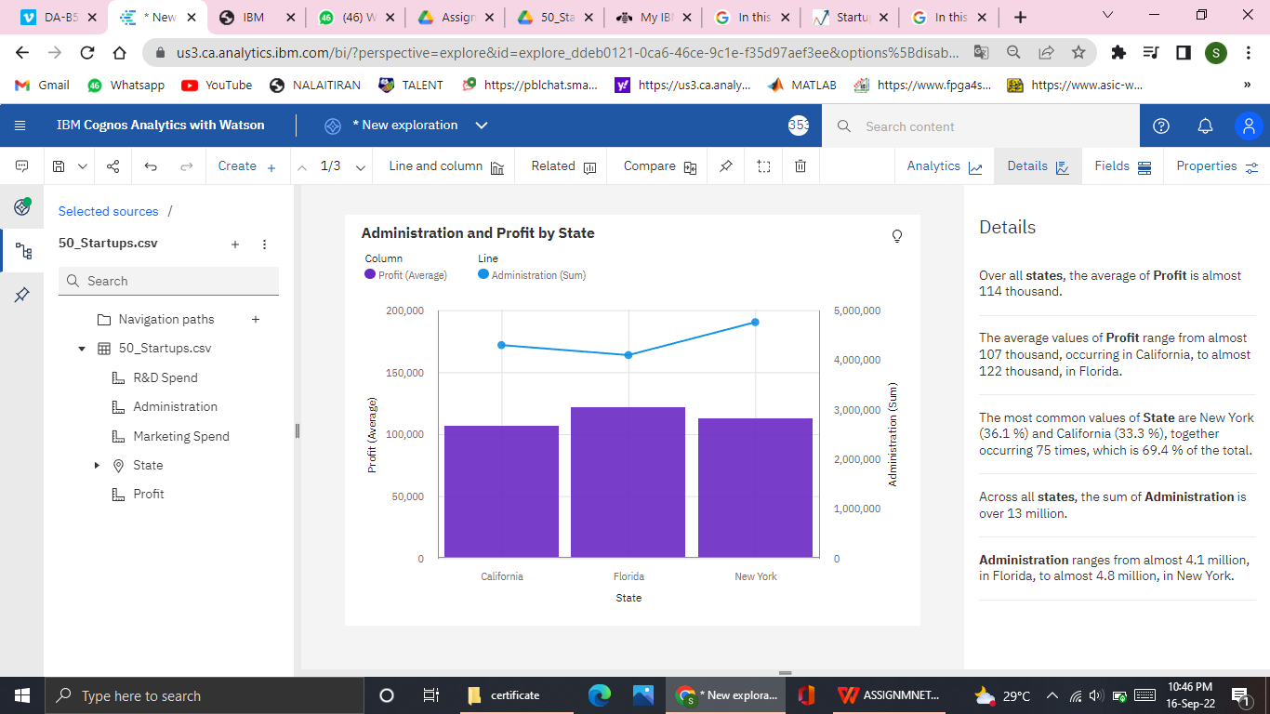

**Profit by R&D Spend colored by Profit ( STACKED BAR)**

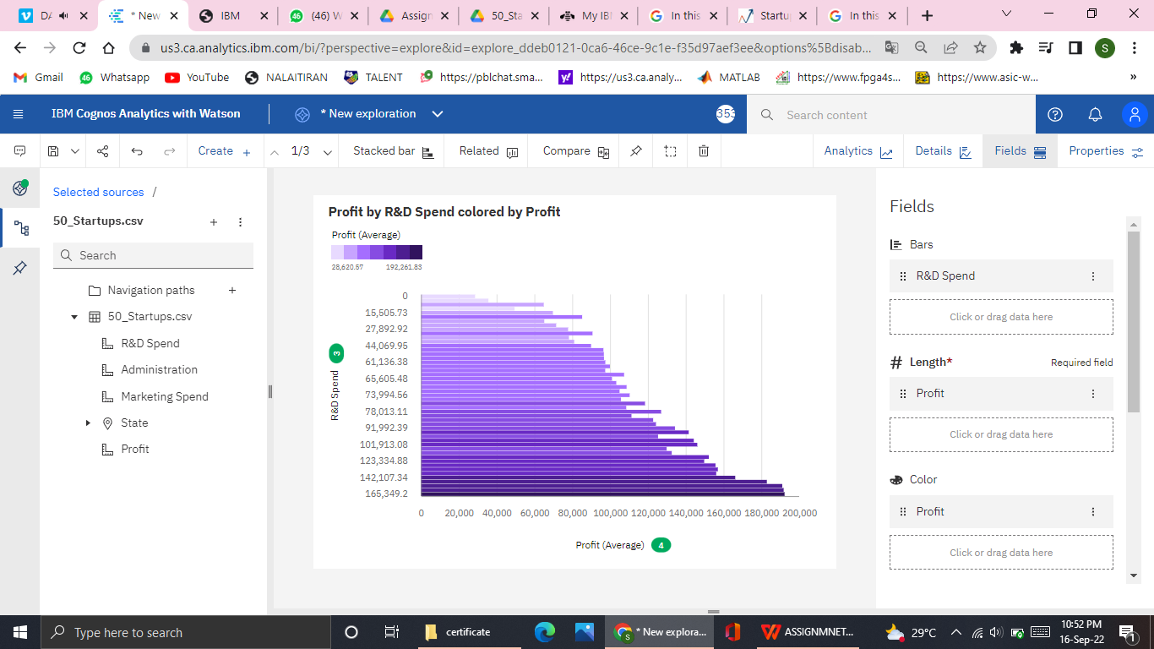

**Profit by State and Administration (AREA)**

